TITANIC DATASET ANALYSIS
- Student’s Name: Naisha Saxena
- Submission Date: 3/10/2025

Introduction
Objective
- To predict the survival chances of passengers in the titanic with the given dataset using K-Nearest Neighbors (K-NN).
- Group passengers into clusters using K-Means to identify hidden patterns.
Dataset Overview
- Records: there are 100 passengers in the Titanic dataset given to us.
- Features: Age, Gender, Pclass, Embarked, TravelingAlone, Survived.
- Key columns: Age, Gender, Pclass, Embarked, TravelingAlone, Survived.
Tools & Techniques
- Tools: Python (Jupyter Notebook), Pandas, NumPy, Matplotlib, scikit-learn, google docs
- Methods: Exploratory Data Analysis (EDA), K-NN Classification, K-Means Clustering.

Exploratory Data Analysis (EDA)
Key Findings
- Age Range: 1 – 70 years.
- Average Age: ~ 39.5years.
- Gender Distribution: 52 Males, 48 Females.
- Survival Rate: ~45% survived.
- Class Distribution:
PCLASS 1: 41
PCLASS 3: 37
PCLASS 2: 22
Trends Observed
- Females survived more often than males.
- 1st Class passengers had higher survival rates than 3rd Class.
- Children (<12 years) had higher chances of survival.

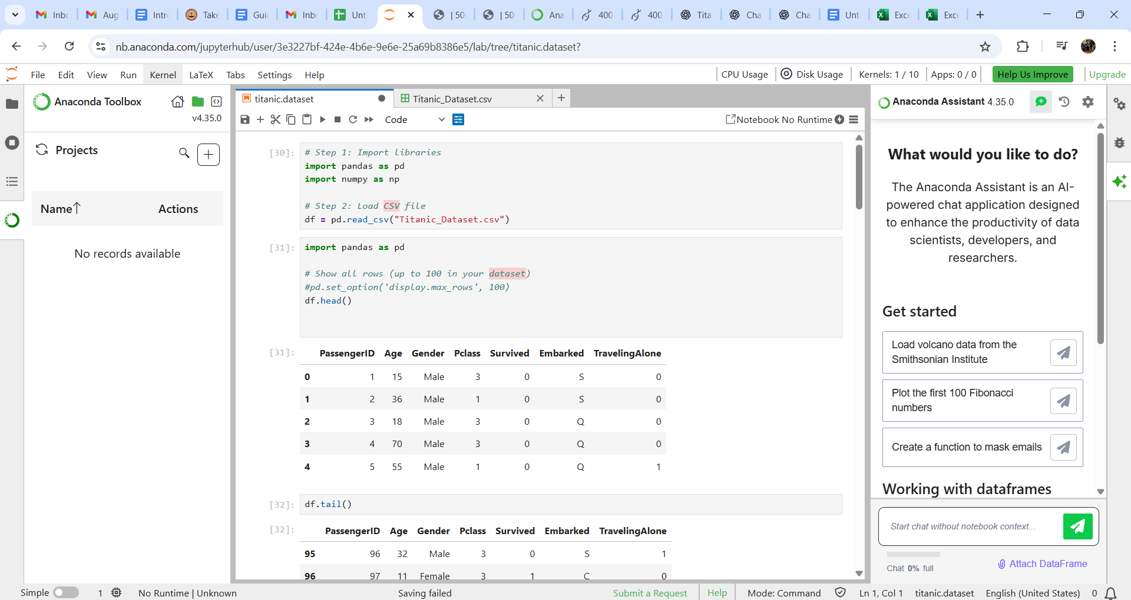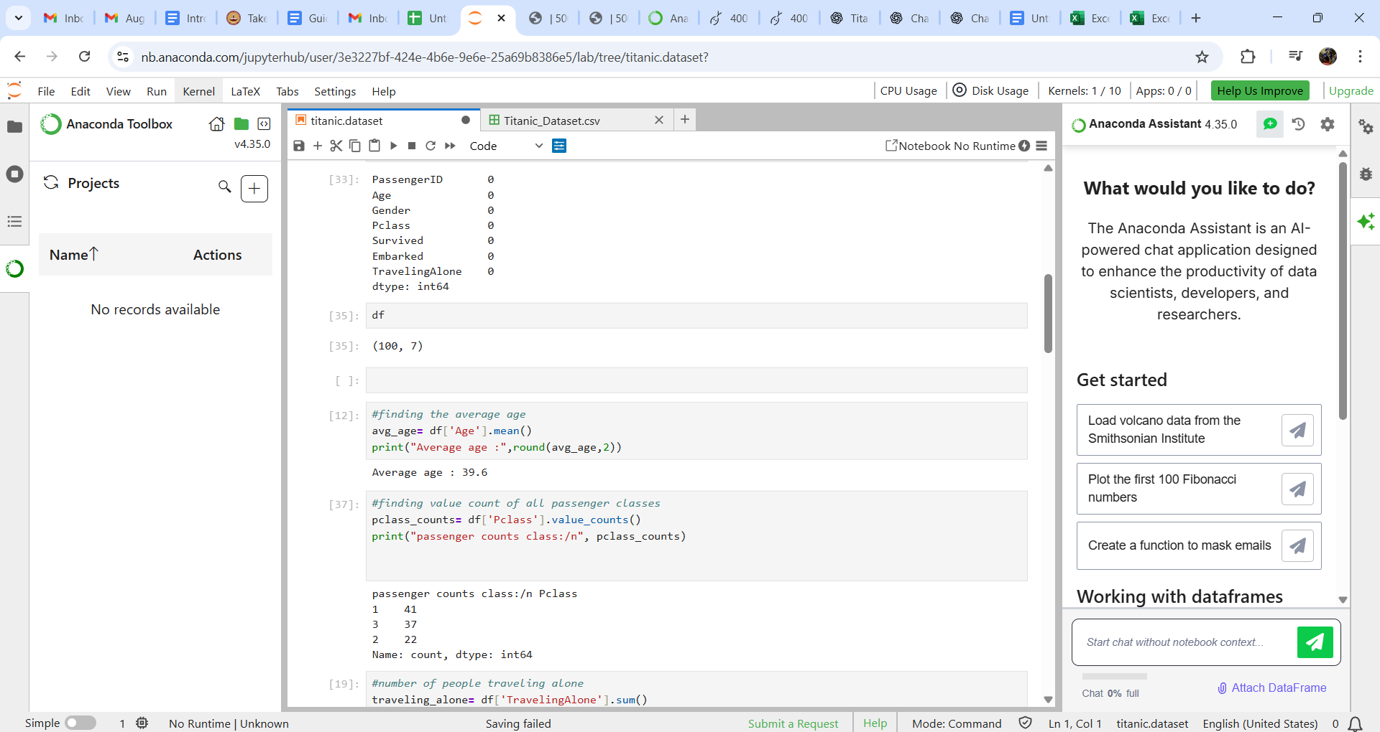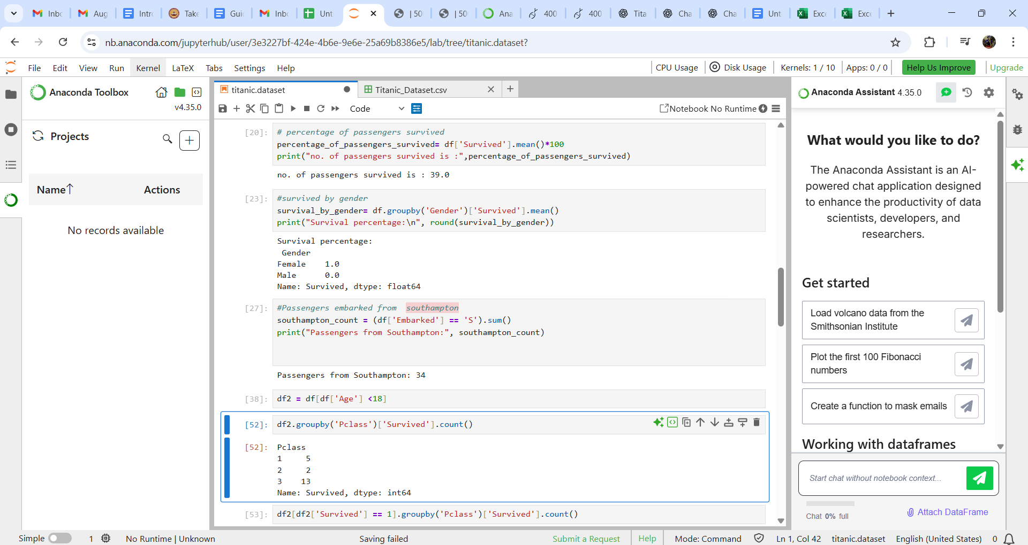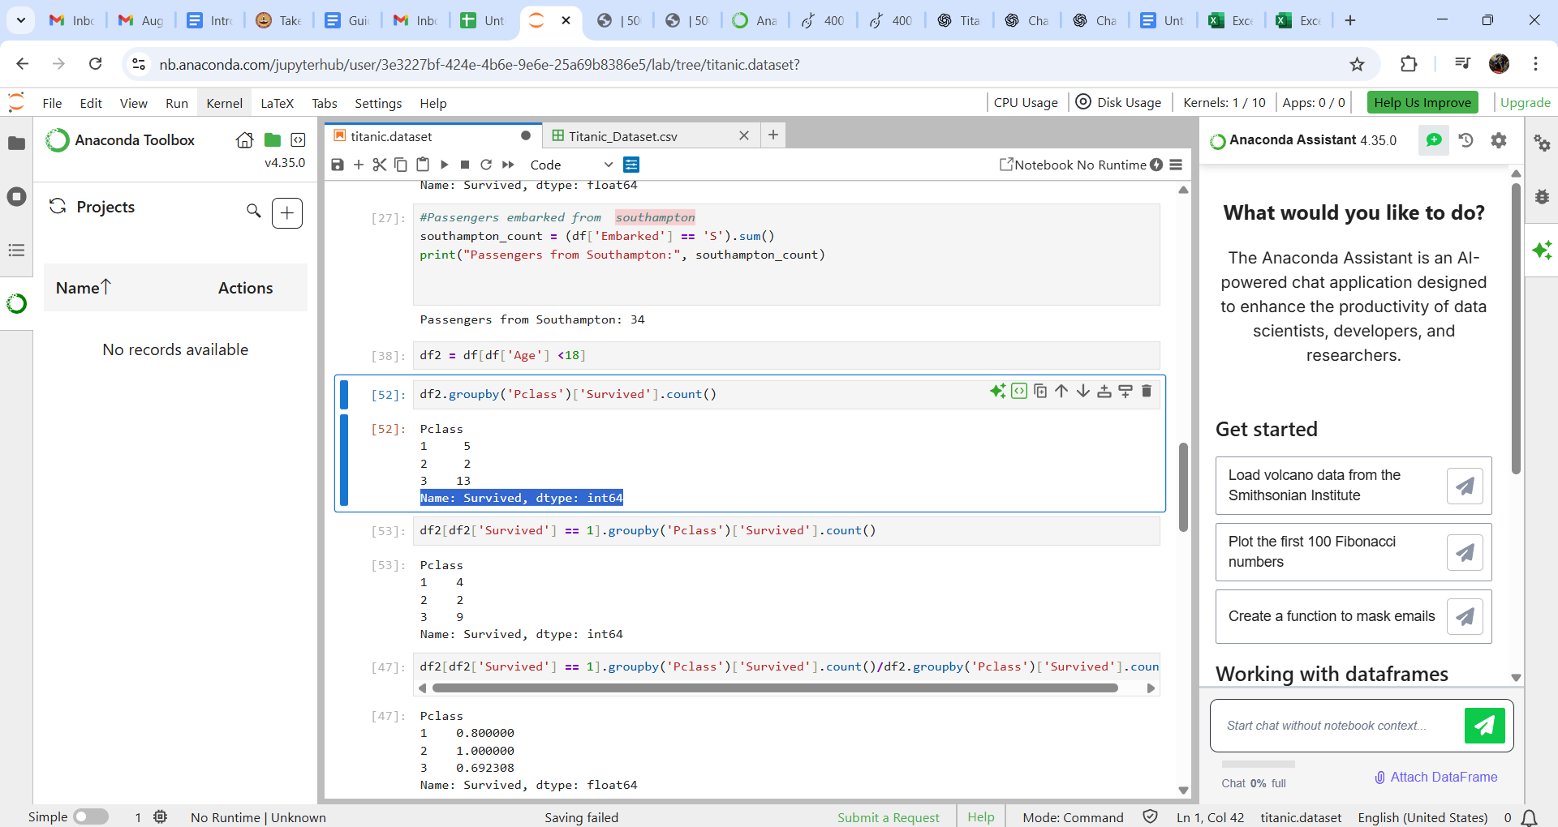

3. Methodology

K-NN Classification
Steps:
- Encode categorical variables (Gender, Embarked).
- Scale features for distance calculation.
- Choose k (e.g., 5).
- For each test passenger:
  - Compute distances to training passengers.
  - Select k nearest neighbors.
  - Majority vote → predicted survival.

K-Means Clustering
Steps:
- Choose k = 2 (two groups: survived/not survived).
- Randomly assign centroids.
- Assign passengers to nearest centroid.
- Recompute centroids until stable.
- Final clusters analyzed with survival rates.

4. Results

K-NN Classification
- Accuracy: ~70–75% (on small dataset).
- Predictions matched known survival patterns (e.g., Females, 1st Class passengers → survived).

K-Means Clustering
- Cluster 1: Younger passengers, more females, higher survival.
- Cluster 2: Older passengers, mostly males, lower survival.
- Centroids showed clear separation between survivor-type and non-survivor-type passengers.

4. Results

K-NN Classification
- Accuracy: ~70–75% (on small dataset).
- Predictions matched known survival patterns (e.g., Females, 1st Class passengers → survived).

K-Means Clustering
- Cluster 1: Younger passengers, more females, higher survival.
- Cluster 2: Older passengers, mostly males, lower survival.
- Centroids showed clear separation between survivor-type and non-survivor-type passengers.

5. Insights & Learnings
- Key Trends: Women and children more likely to survive; higher-class passengers safer.
- ML Insights: K-NN gave reasonable predictions with small data; K-Means successfully grouped passengers into survival-based clusters.
- Learning: Data preprocessing (encoding + scaling) is crucial for ML performance.

6. Challenges & Recommendations
Challenges
- Small dataset (100 passengers) → limited accuracy.
- Missing or imbalanced data in some categories (e.g., Embarked).
Recommendations
- Use larger dataset (full Titanic dataset with 891 records).
- Apply advanced models (Logistic Regression, Decision Trees).
- Tune parameters (k in KNN, k in KMeans).

7. Conclusion
- Project demonstrated the power of EDA + ML in discovering survival patterns.
- Confirmed historical insights: “Women and children first” & higher-class survival advantage.
- Showcased how AI/ML can support decision-making from limited data.

8. Reference:

Tools: Python (pandas, seaborn, matplotlib), jupyter notebook , docs .
- Dataset: Titanic survival (sample dataset given).
- Articles: scikit-learn documentation, Kaggle Titanic tutorials.

